Setting Up the WeBots Environment

From GitHub to Your Local Computer
This is the windows version for setting up your computer but should work similarly if you are using a Mac.

1.1 Creating a Branch and Copying Repository
- On the repository for the project, click the drop down in the left hand side to view all branches. Click the “View all branches” option.
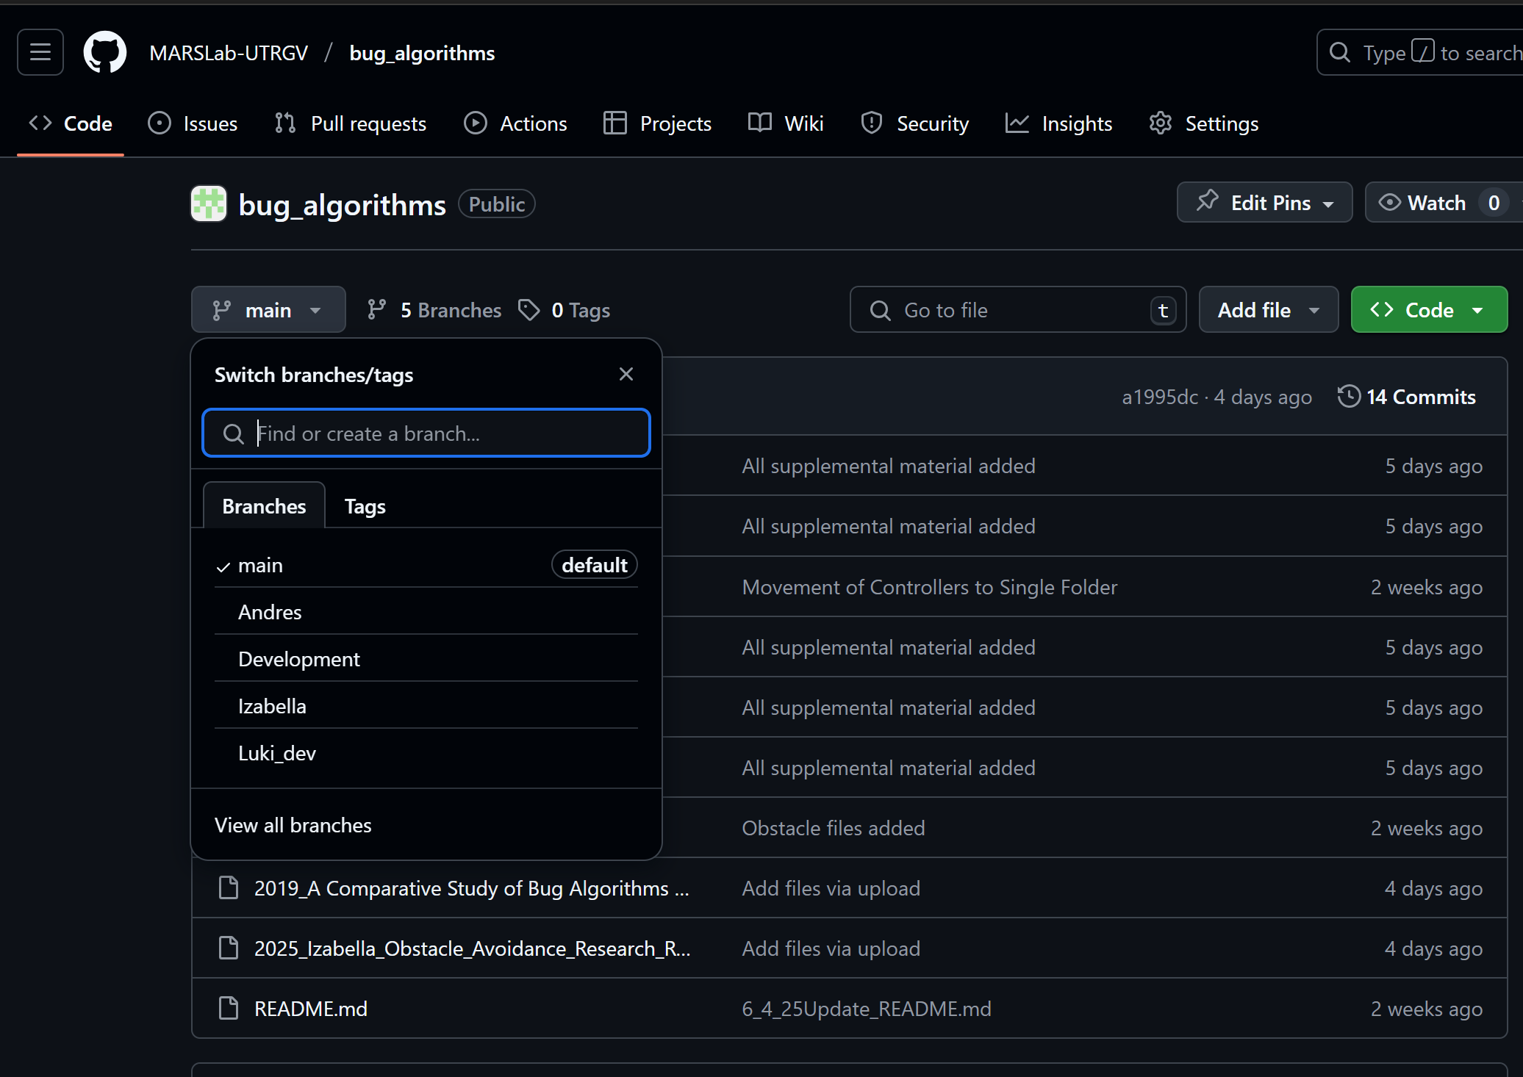
- Click the “New Branch” option in the top right hand side.
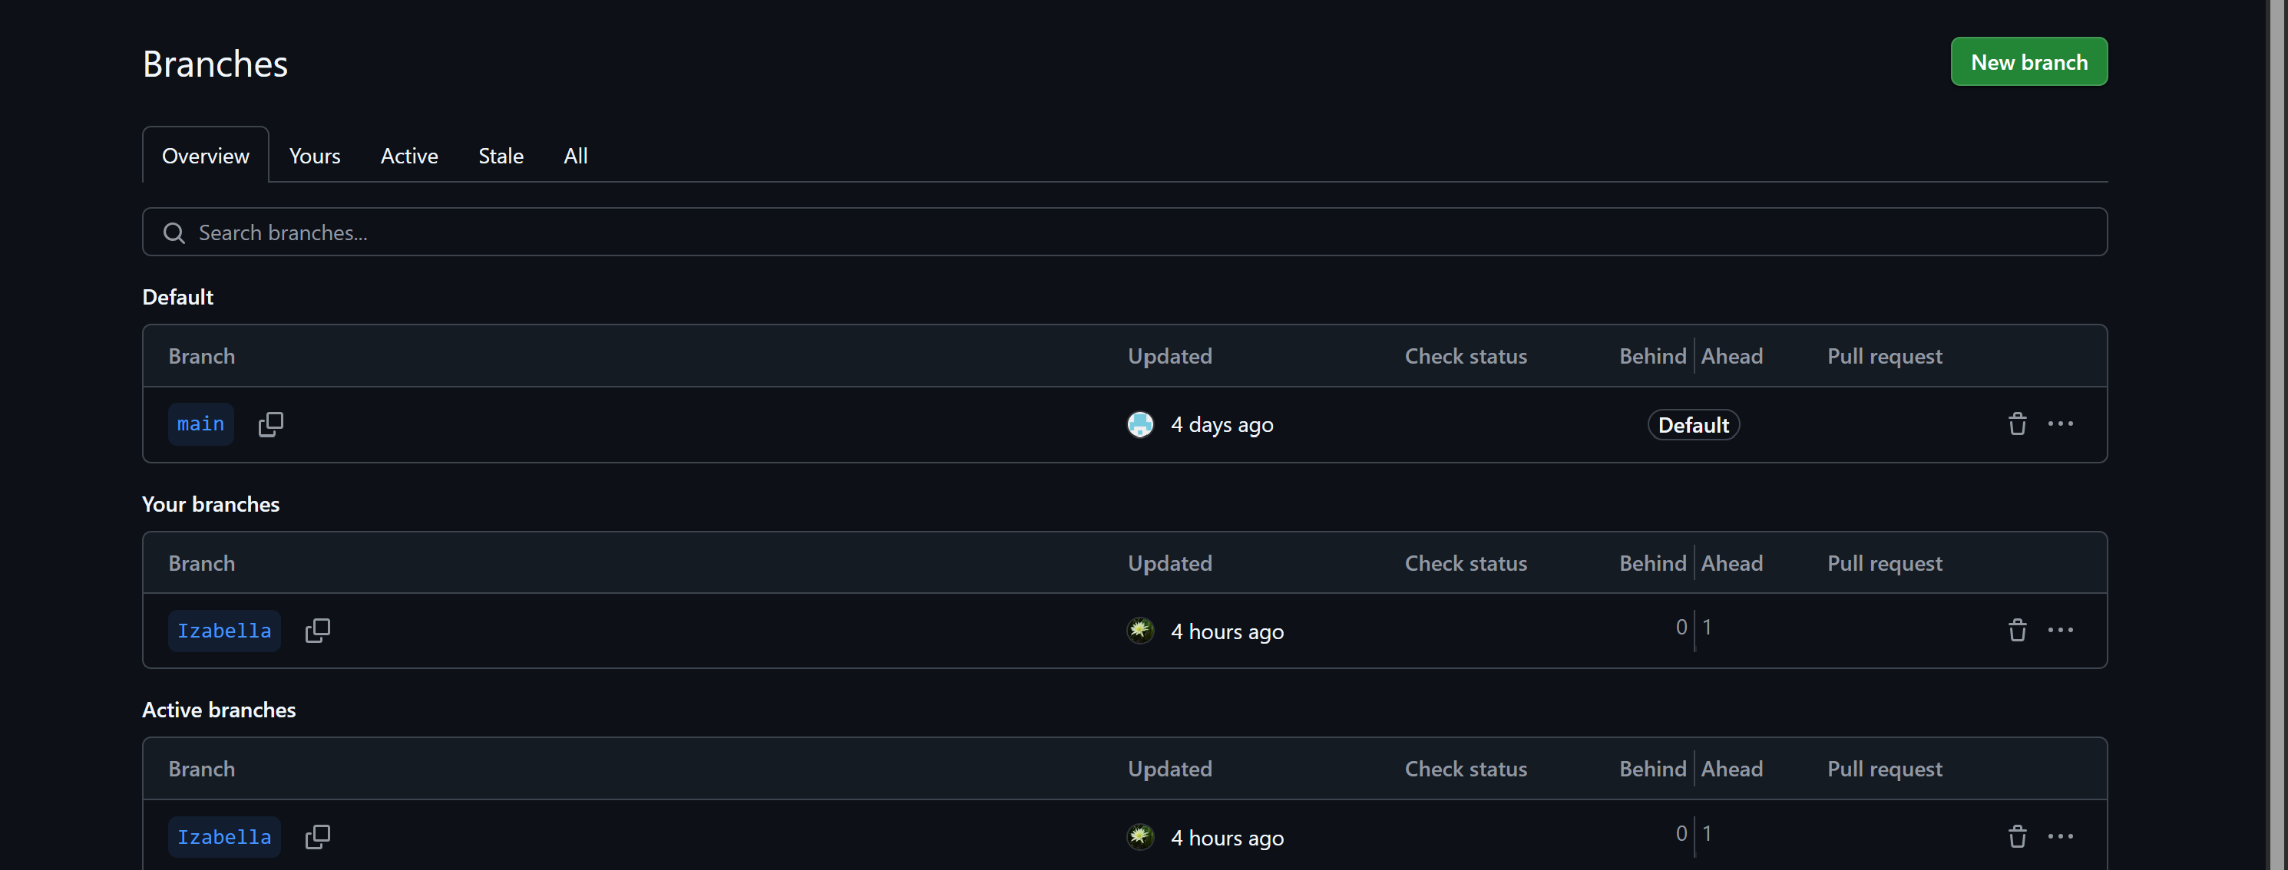
- Type in your name to create the branch and click the button “Create new branch”
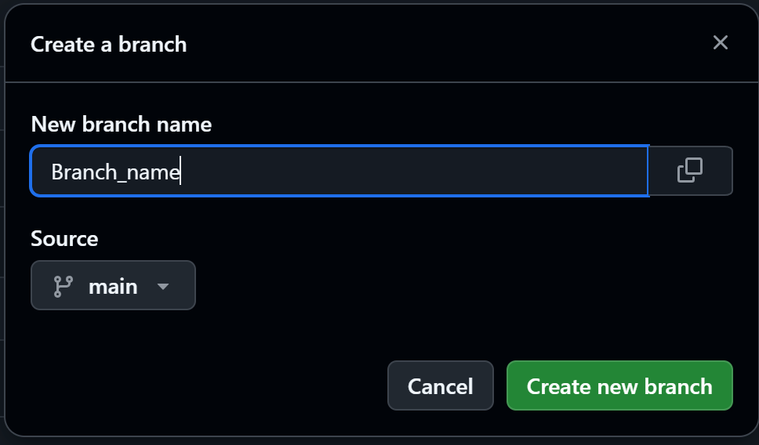
- Navigate to the main page of the repository and change the branch to the one with your name.
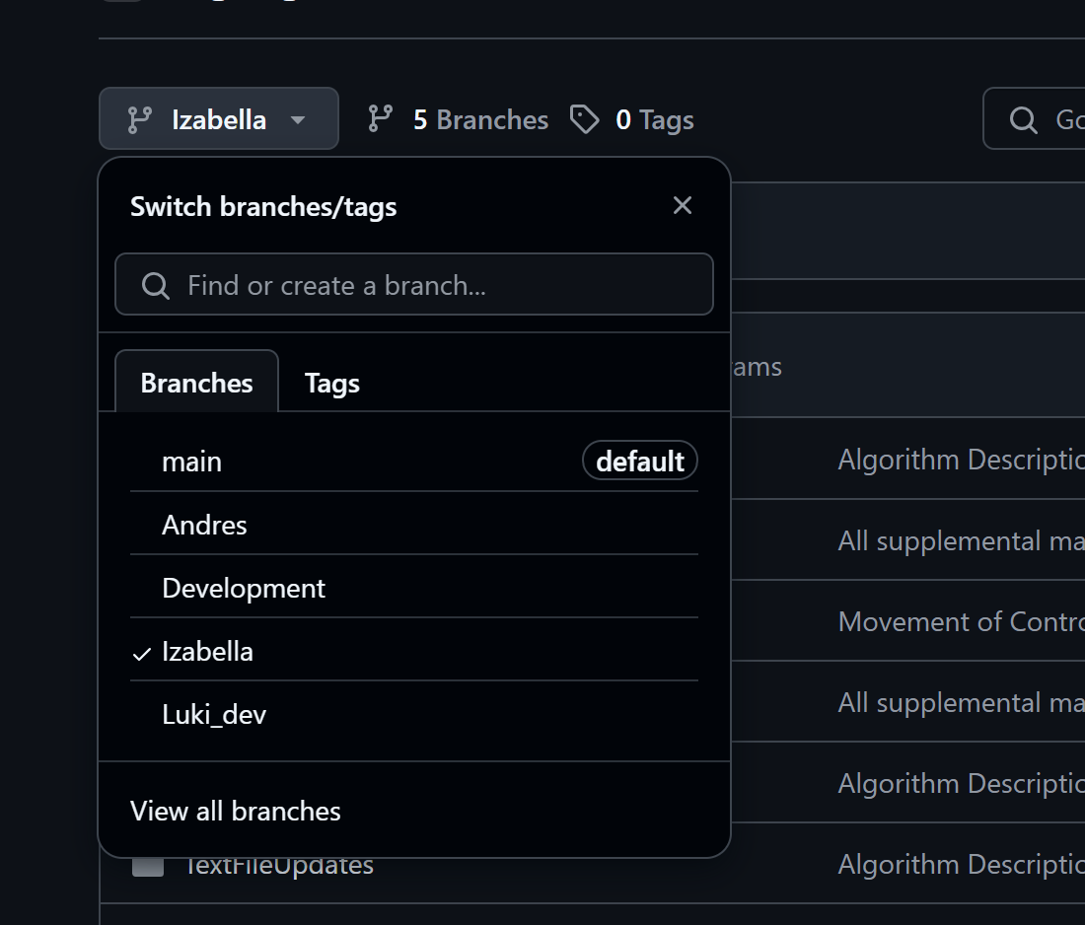
- After changing to your branch, click the “<>Code” drop down on the right hand side. In this drop down click the copy icon to copy the HTTPS link. This will be important for the next step.
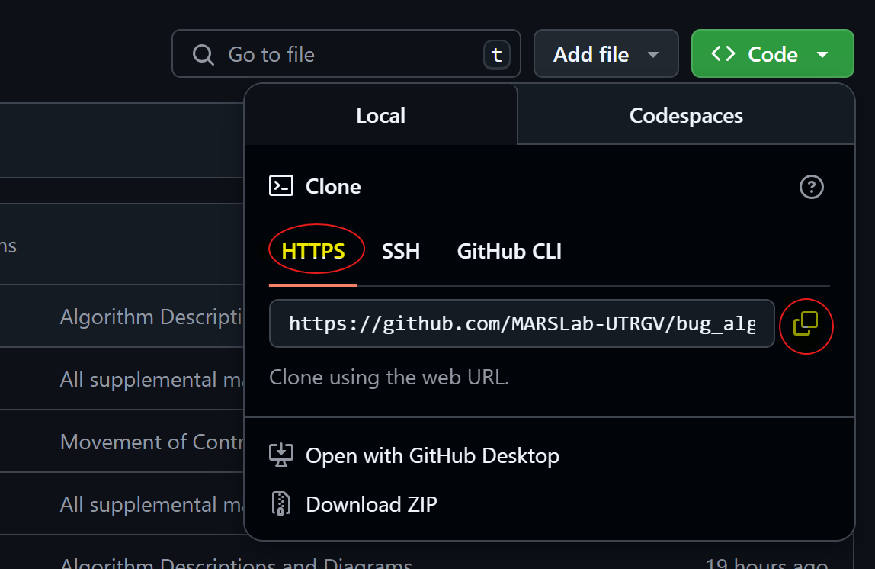
- Choose a space on your computer via File Explorer to store and access locally. Preferably one that you can navigate to. For example: Desktop -> MarsLabWork -> GitHubFile. Remember the path and how to reach this file.


Pasting Repository to Your Local Files
- In the space where you navigated to, you can either right click to open the terminal or use the Windows Search to open the command prompt.
Open using the windows search on the navigation bar and searching “Command Prompt”
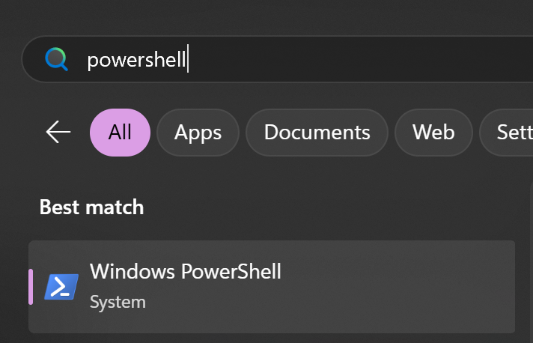
Or Open Terminal with a Right Click and clicking the “Open in Terminal Option”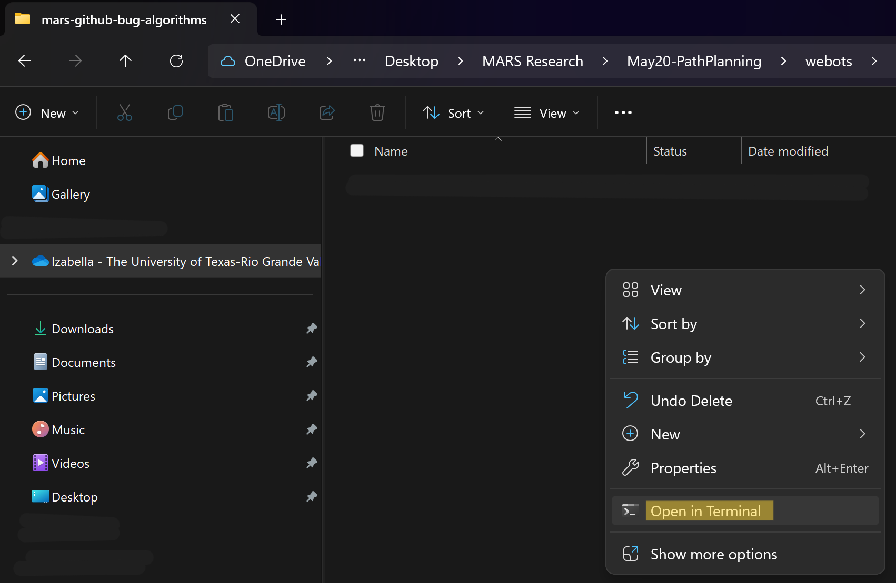
The option using the File Explorer is the preferred option since you will not have to navigate to the folder in the command prompt.
- Navigating to the folder VIA command prompt. NOTE: This is only if you used the search option in step 1. If you opened it in the file already, you may skip this step.
You will begin in your home directory. You can use the cd command to change to a file. There are multiple ways to do this. Only the commands will be included in this documentation since you should know where your file is (Refer to path in 1.1 Step 6).
- ls can be used to see all the files in a directory.
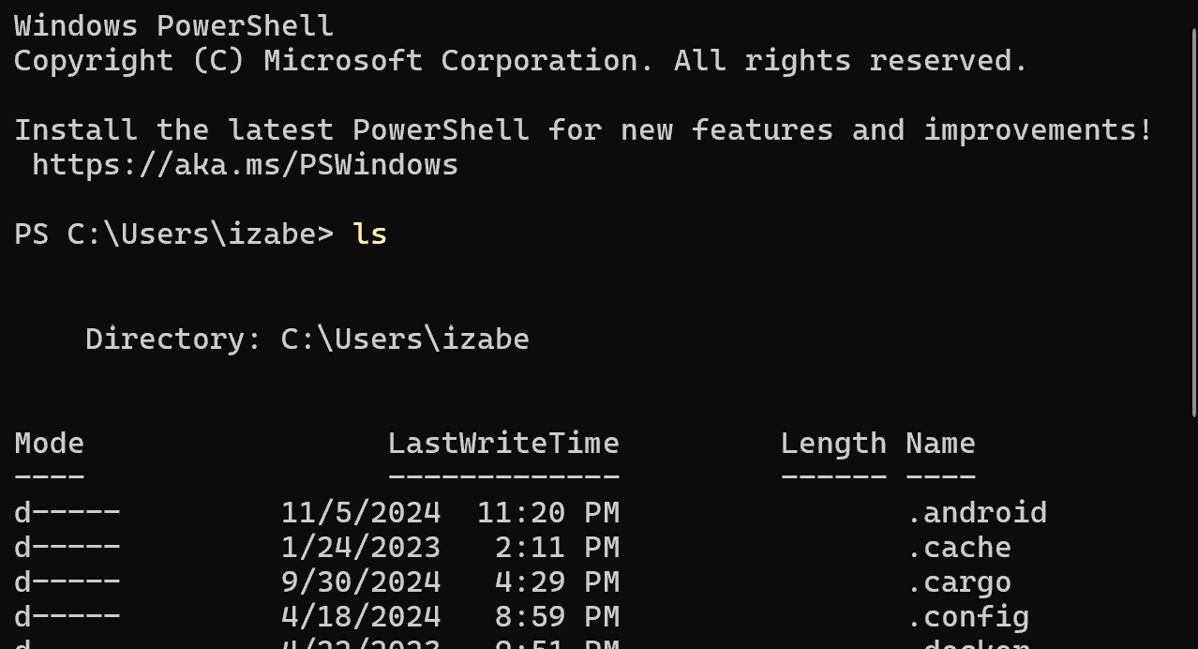

-cd allows to change directory.
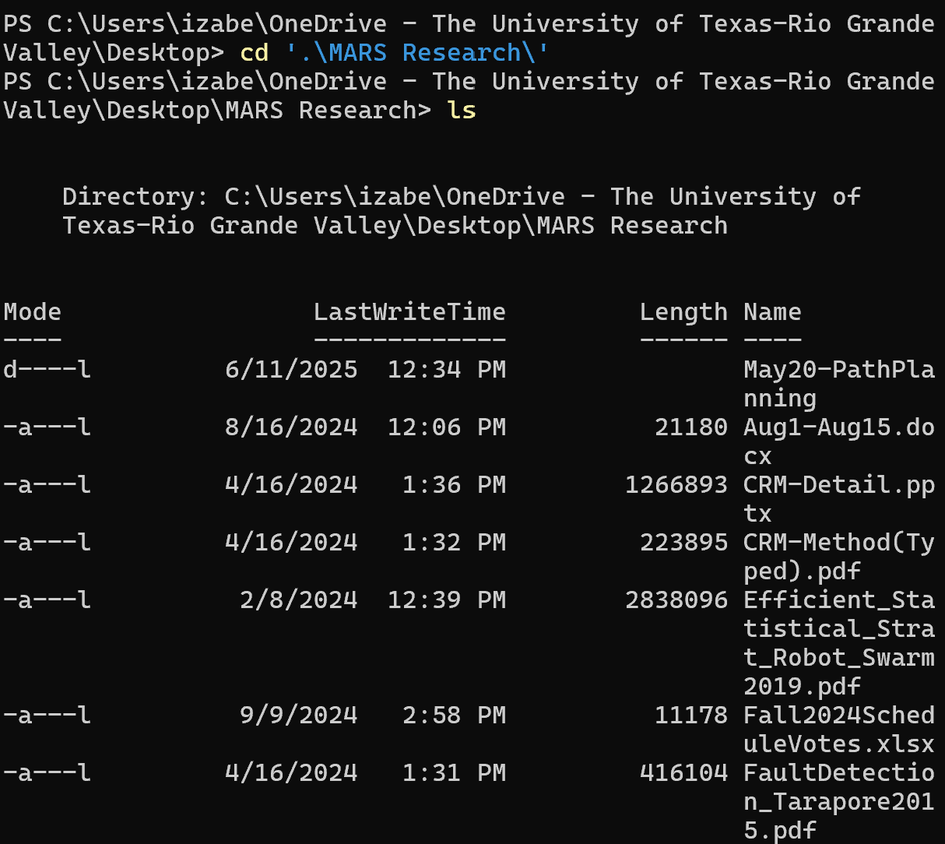
When using the CD option, you can type the first few letters and then press the ‘TAB’ key on your keyboard to automatically fill it in. This only works with unique names. For the example above the ‘MA’ of mars was typed before pressing TAB.
The CD command can also change multiple directories at once. If you copied/remember the path from 1.1 step 6, you can paste/type it after the CD command. For example a full path of \Desktop\MARS Research\May20-PathPlanning\Webots\ will take you all the way to the Webots file.

- Ensure git is installed and part of your path directory to continue to clone. If it is not, install git to your computer and ensure it is in your PATH environment. You can skip this step if you already have git installed.
To check if installed: git –version
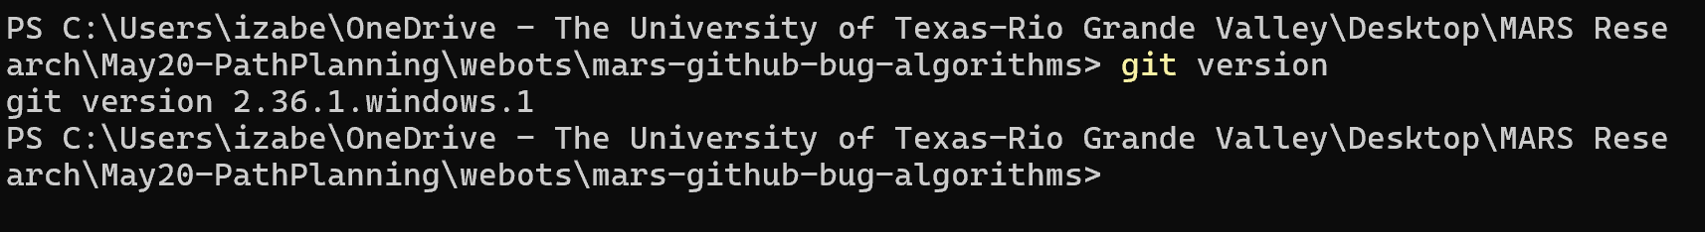

If you get a different output than the one above, you will have to install git.
These tutorials to install it.
https://www.answerlookup.com/how-add-git-windows-path-environment-variable
https://www.w3schools.com/git/git_install.asp?remote=github

- In the file you navigated to you can clone the repository. This will use the HTTPS link you copied from GitHub.
Use: git clone <repository-name>
Once cloned it should give you a success message. You now have the repository on your local desktop!

Branch Security
All your work MUST be done on your branch!!! Each person has their own branch and they must push to that Branch only until they have completed the portion of work given. This section will instruct you how to navigate to your branch and how to check what branch you are in. Reminder: You must work in your branch every time you edit, NEVER in main.
- Check what branch you are in using:
git branch
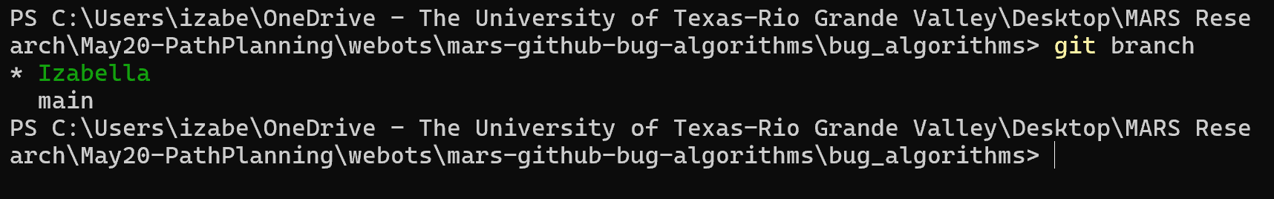
This shows that I am in the branch named Izabella. If you are in the main branch follow the next steps to navigate to your branch.

- Use:
git switch <branch-name>
or
git checkout <branch-name>

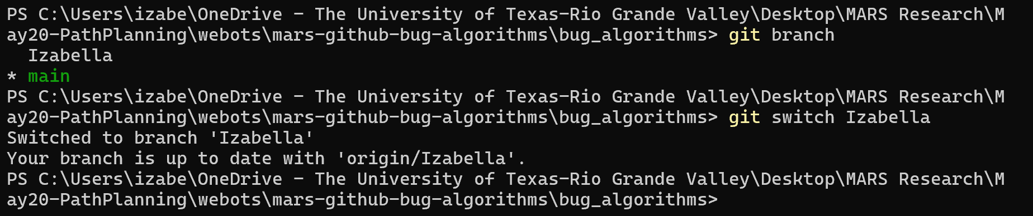
Both should result in the same outcome and updated message.

- Once you are in the branch you can use the command:
git pull

This will allow you to pull any material that is not on your local device and was added to the branch. This may not be of necessity since you alone are working on your branch. This will come in handy later when you need to pull from main or from the ‘Development’ branch.

- After editing any work you can use the series of commands to have a successful commit and push. REMINDER! All changes should have been made in your branch. Check if you are in your branch before pushing. The git status is not necessary but allows you to visualize what you are pushing.

git status
git add .
git status
git commit -m ‘commit message’
git status
git push
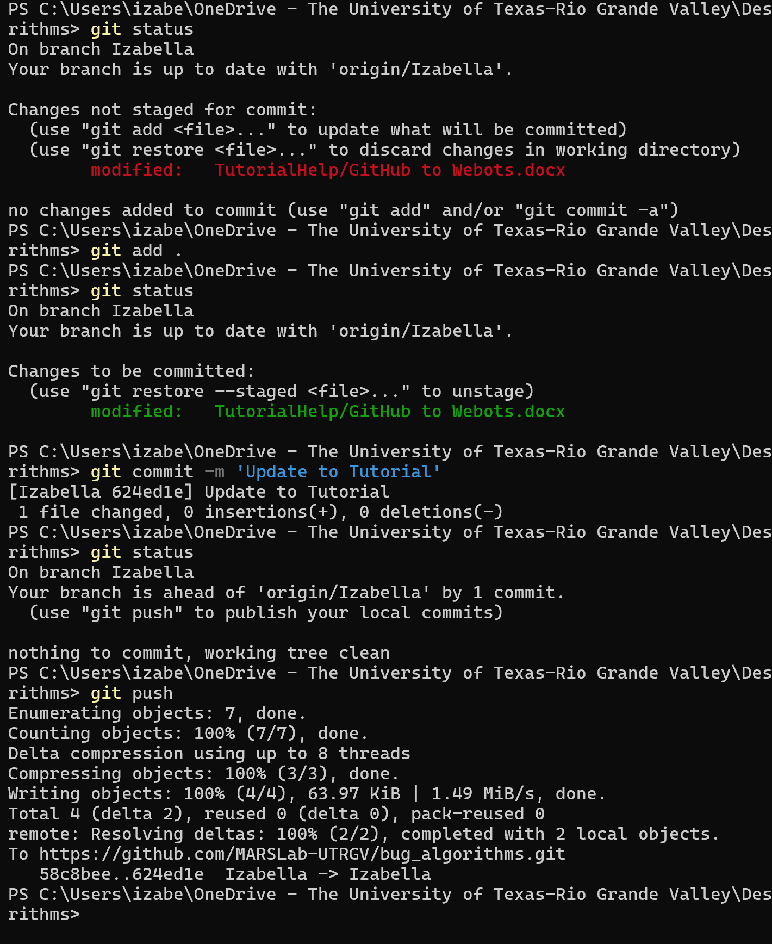

git add can also individually add files to push when removing the ‘.’ . It can be used as:

git add <file-name>

For more details and information about using git push commands, please visit:
https://github.com/git-guides/git-push
The development branch will be where major completed work will be pushed to. This is before adding it to main so I can alter anything that goes wrong and have a successful merge. The link above shows you how to push to that branch. It will be:
git push -u origin Development

PLEASE DO NOT USE THIS COMMAND WHILE FOLLOWING THIS TUTORIAL. It shouldn’t alter anything, but it is not a necessary item to use. However, I do want you to have the knowledge that we will be merging all of our branch work to the development periodically.

Webots
Now that you have git installed and the GitHub repository on your local device it should be relatively easy to use Webots. For the purpose of this demonstration, you will need to insure that python is installed on your device. This will not be included in this tutorial, however there are multiple you can search or even ask ChatGPT for instructions and information on how to do so.
- Open file explorer and navigate to the repository that you cloned.
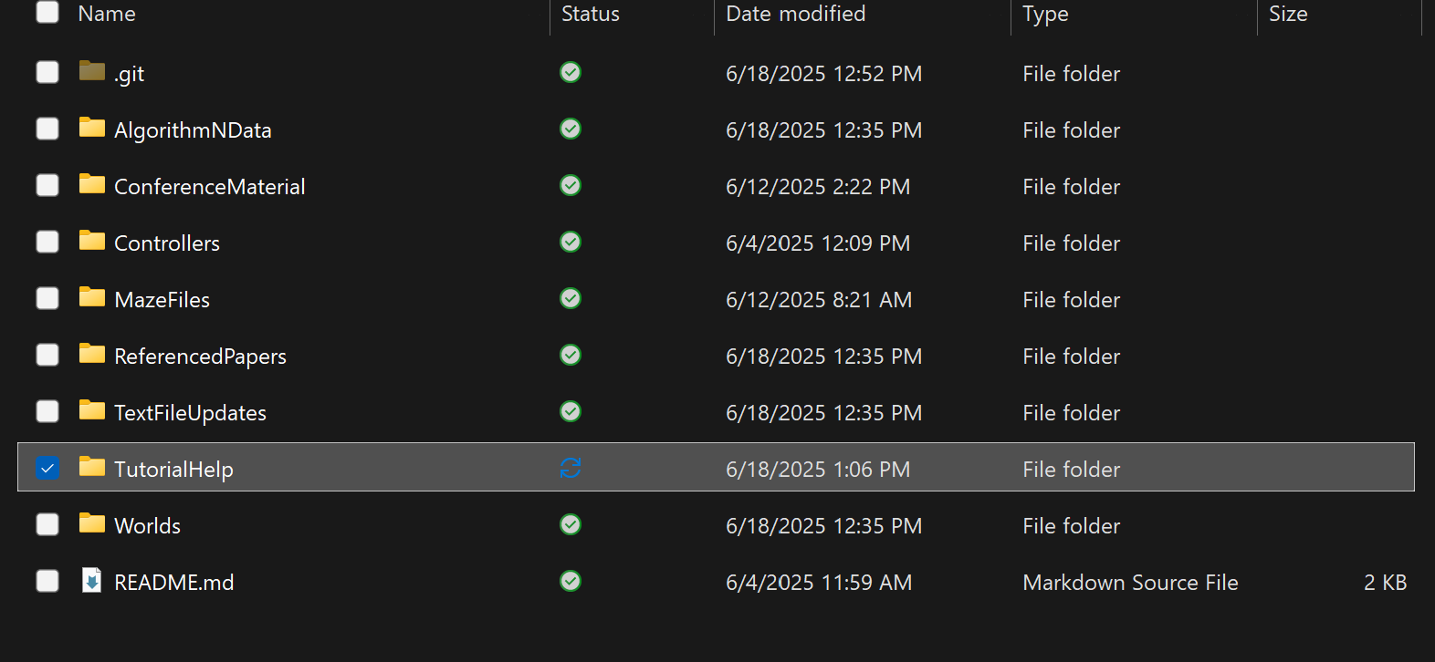
- Explore the contents of the “Controllers” file. This is where all of the algorithms reside. All of these should be available to you when you open the WeBots application from the repository on your local device. Most of them are complete with the exception of AltComboBug. Please do not touch this file as it is currently in active editing and will cause merge conflicts.
- Return to the full repository and open the “Worlds” file. All of these are the maps that have been tested on. The H stands for horizontal meaning the robot and goal are horizontal from each other and V stands for vertical. Do not alter the names unless otherwise instructed. To test out and experiment with these maps, open any of these world files and it should automatically open in WeBots. Now that you are in the Webots application you can begin to run it.
- In the scene tree on the left-hand side, open the drop down for the Robot
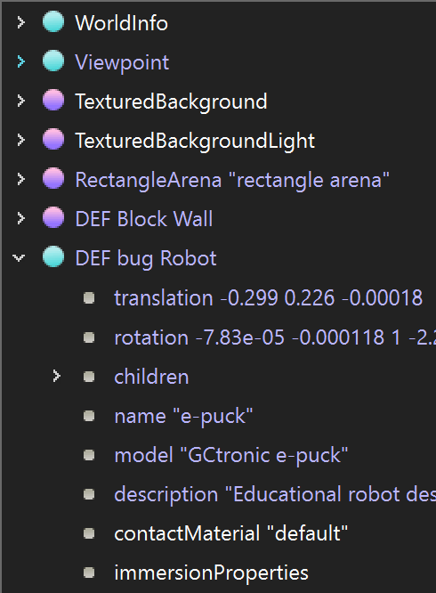
- Scroll down to find the “controller” and click on it. This will tell you which algorithm controller is active on the robot.
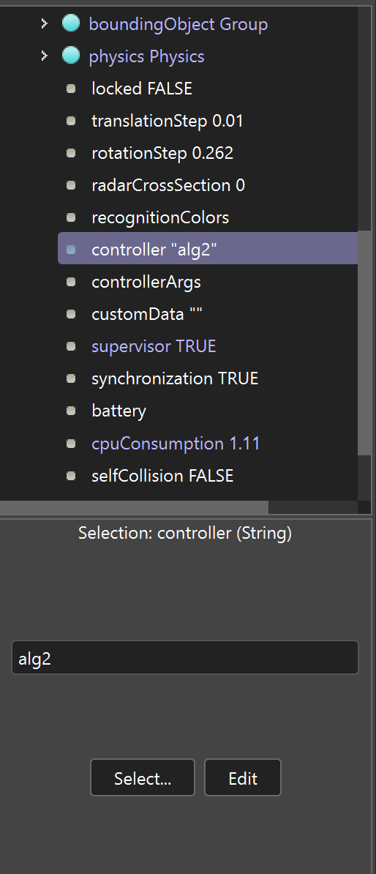
- To select a new controller, click the “Select…” Button. This will give a pop up with all the algorithms that should be in the “Controllers” file.
- The following pop up should show you all the algorithms. From here you can click the one you want to test and then click the OK button.
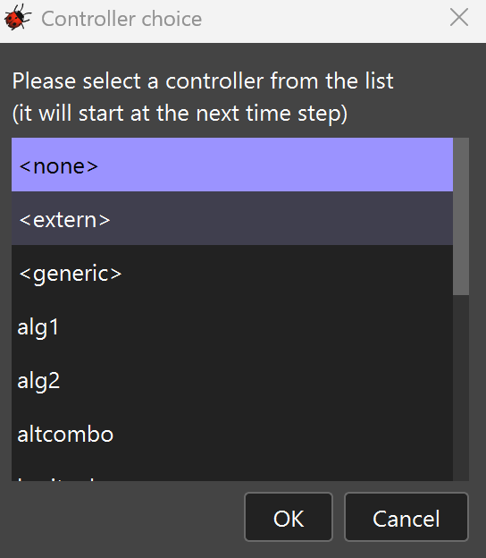
- Now click the save button at the top of the screen on the tool bar (the red circle on the leftmost side) before reloading the environment by clicking the Reload World button (the middle red circle). Then you can press play (the rightmost red circle) and watch the robot interact with the environment according to its algorithm.

